1)WAP to print even number series

//WAP to print even number series

#include <iostream.h>
#include <conio.h>
main()
{
clrscr();
int n;
cout<<"\n\n\n\t Enter Max value ";
cin>>n;
for(int i=2;i<=n;i+=2)
cout<<i<<"\t";
getch();
}
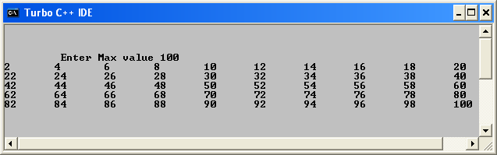

2)WAP to print odd number series

//WAP to print odd number series
#include <iostream.h>
#include <conio.h>
main()
{
clrscr();
int n;
cout<<"\n\n\n\t Enter Max value ";
cin>>n;
for(int i=1;i<=n;i+=2)
cout<<i<<"\t";
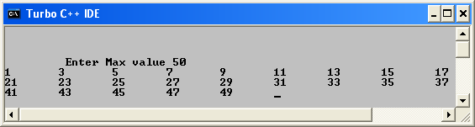
getch();
}

3) WAP to print square series
//WAP to print square series
#include <iostream.h>
#include <conio.h>
main()
{
clrscr();
int n;
cout<<"\n\n\n\t Enter Max value ";
cin>>n;
for(int i=1;i<=n;i+=2)
cout<<i<<"\t";
getch();
}

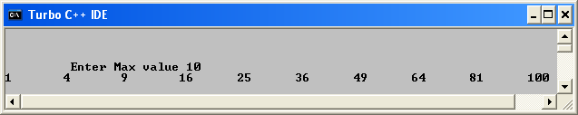

4)WAP to print even square series

WAP to print even square series
#include <iostream.h>
#include <conio.h>
main()
{
clrscr();
int n;
cout<<"\n\n\n\t Enter Max value ";
cin>>n;
for(int i=2;i<=n;i+=2)
cout<<i*i<<"\t";
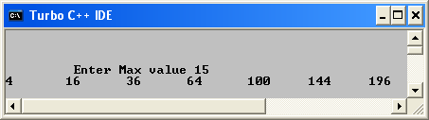
getch();
}

5) WAP to print odd square series

WAP to print odd square series
#include <iostream.h>
#include <conio.h>
main()
{
clrscr();
int n;
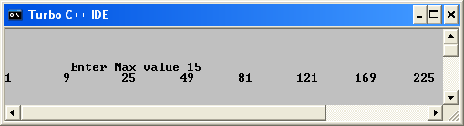
cout<<"\n\n\n\t Enter Max value ";
cin>>n;
for(int i=1;i<=n;i+=2)
cout<<i*i<<"\t";
getch();
}

6)WAP to print Fibonacci series

//WAP to print Fibonacci series
#include<iostream.h>
#include<conio.h>
main()
{
clrscr();
int n;
cout<<"\n\n Enter max value ";
cin>>n;
int i=0,j=1,sum;
cout<<"\n\n" <<i<<"\t"<<j;
while(i<=n && j<=n && sum<=n)
{
sum=i+j;
cout<<"\t"<<sum;
//swapping of i and j
i=i+j;
j=i-j;
i=i-j;
//swapping of sum and j
j=j+sum;
sum=j-sum;
j=j-sum;
}
getch();
}
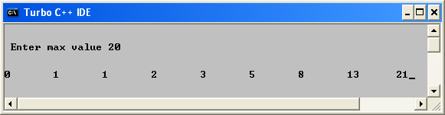

7) WAP to print lucas series

//WAP to print lucas series
#include<iostream.h>
#include<conio.h>
main()
{
clrscr();
int n;
cout<<"\n\n Enter max value ";
cin>>n;
int i=1,j=3,sum;
cout<<"\n\n" <<i<<"\t"<<j;
while(i<=n && j<=n && sum<=n)
{
sum=i+j;
cout<<"\t"<<sum;
//swapping of i and j
i=i+j;
j=i-j;
i=i-j;
//swapping of sum and j
j=j+sum;
sum=j-sum;
j=j-sum;
}
getch();
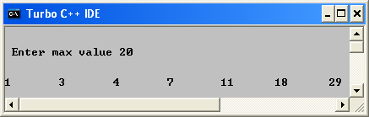
}

8) WAP to print reverse of a number

//WAP to print reverse of a number
#include<iostream.h>
#include<conio.h>
main()
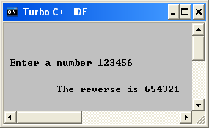
{
clrscr();
long int num,rev=0,rem;
cout<<"\n\n\n\n Enter a number ";
cin>>num;
while(num>0)
{
rem=num%10;
rev=rev*10+rem;
num=num/10;
}

cout<<"\n\n\t The reverse is "<<rev;

getch();
}

9) WAP to print number of digits

//WAP to print number of digits
#include<iostream.h>
#include<conio.h>
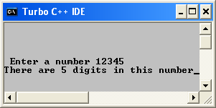
main()
{
clrscr();
long num;
cout<<"\n\n\n\n Enter a number ";
cin>>num;
for(long flag=0;num>0;flag++)
num=num/10;
cout<<"There are "<<flag<<" digits in this number";
getch();
}

10) WAP to print sum of digits

//WAP to print sum of digits
#include<iostream.h>
#include<conio.h>
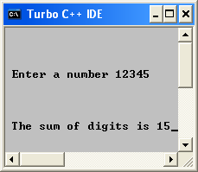
main()
{
clrscr();
long num,sm=0,rem;
cout<<"\n\n\n\n Enter a number ";
cin>>num;
while(num>0)
{
rem=num%10;
sm+=rem;
num=num/10;
}
cout<<"\n\n\n\n The sum of digits is "<<sm;
getch();
}

11) WAP to print if it is a palindrome or not

//WAP to print if it is a palindrome or not
#include<iostream.h>
#include<conio.h>
main()
{
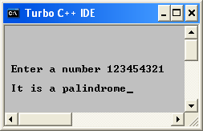
clrscr();
long int num,rev=0,rem,eq;
cout<<"\n\n\n\n Enter a number ";
cin>>eq;
num=eq;
while(num>0)
{
rem=num%10;
rev=rev*10+rem;
num=num/10;
}
if(rev==eq)
cout<<"\n It is a palindrome";
else
cout<<"\n It is not a palindrome";

getch();
}

12) WAP to print sum of powers of a number upto n

// WAP to print sum of powers of a number upto n
#include<iostream.h>
#include<conio.h>
#include<math.h>
main()
{
clrscr();
int pw=0,exp,sum=0,a;
cout<<"\n\n\n Enter the exponent ";
cin>>exp;
cout<<"\n\n\n Enter the maximum value of power ";
cin>>pw;

while (pw>=0)
{
a=pow(exp,pw);
sum=sum+a;
pw=pw-- ;
}
cout<<"The sum is "<<sum;
getch();
}
